**Practical No: 10.2**

**Practical Title: Program for 3 Dimensional Transformations (Scaling)**

**Roll no: Batch: Date of performance:**

#include<stdio.h>

#include<conio.h>

#include<graphics.h>

#include<process.h>

#include<math.h>

int maxx,maxy,midx,midy;

void main()

{

int gd=DETECT,gm,x,y,z;

initgraph(&gd,&gm,"C:\\TC\\BGI");

maxx=getmaxx();

maxy=getmaxy();

midx=maxx/2;

midy=maxy/2;

line(midx,0,midx,maxy);

line(0,midy,maxx,midy);

bar3d(midx+50,midy-100,midx+60,midy-90,5,1);

printf("\t\t\tEnter Scaling factor: ");

scanf("%d %d %d",&x,&y,&z);

printf("\t\t\tAfter Scaling:\n");

bar3d(midx+(x*50),midy-(y*100),midx+(x*60),midy-(y*90),5*z,1);

getch();

closegraph();

}

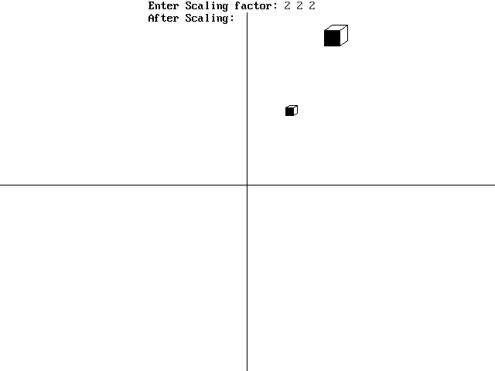**OUTPUT:**